There are 10 bianks, numbered 28 to 38, in the passage below. From the list of words  
given, choose the most suitable word for each blank, Write its letter (A to Q) in the  
blank. The letters (1) and (OQ) have been omitted in order to avoid confusion during  
arking. (10 marks)

FACH WORD CAN BE USED ONLY ONCE.

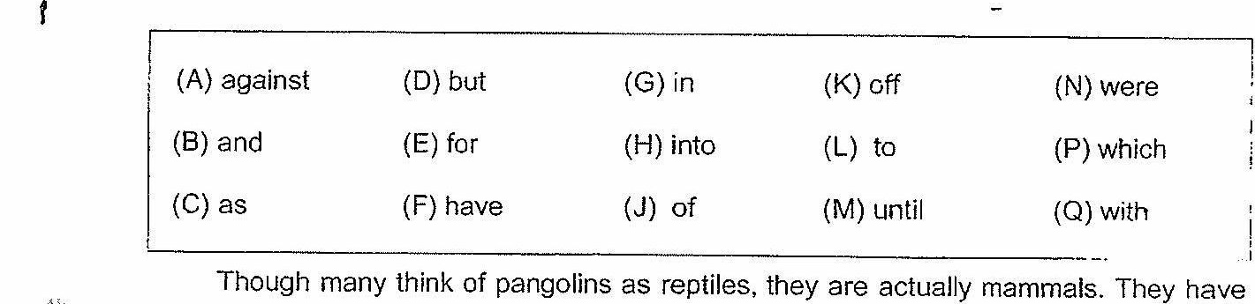

large protective keratin scales covering their skin and are the only known mammals

(29) _________, fhis feature. With its foreclaws hanging just (30) the

ground, It looks like @ miniature T-rex (31) _________ it ambles along on its hind legs.

The scaly mammal’s formidable foreclaws are built not for walking, (32) for

ripping open ant hills and termite nests

Winen in danger, it may curl (33) (eyprty) a ball, relying on its armour of scales

tO protect lis conical head and delicate underbelly. Unfortunately, that armour is no protection

(S4) _________ cars travelling at high speed.

Hurnched close to the ground, the pangolin is hard (35) _________. any driver to

spot on the road. If itis caught (36) _________ the headlights of a vehicle, the shy

creature may freeze, and even when fleeing, it can only rev up (37) _________ aman’s

jogging pace.

According to the National Parks Board (NParks), an average of iwo pangoalins a year

were found dead on major roads around the Bukit Timah and Central Catchment nature

reserves from 1994 to 2014. That number may not seem a lot (38) _________ one

reaises that the tolaf number of wild pangolins in Singapore may be just more than 50.  
d ar \ |

In Singapore, it is illegal uncer the Wild Animals and Birds Act to remove pangolins.

frora the wild. Those found in nature reserves are also protected by the Parks and Trees Act

Adapted rom Pitps.//graphies. siraitstimes. comiS TUS TIME DIAM Interactivesy201 8/1 Lfeature- : |  
enolink-EBEKF -naiional-narte! i